**Introduction:**

In eCommerce logistics, there are a lot of factors that will determine the outcome of the delivery but last-mile and last-yard delivery is a topic that is frequently and seriously discussed. But because customers now have greater expectations for delivery, "last-yard delivery" has become a key area of attention for eCommerce companies. In supply chain management, "last-mile delivery" takes place at the destination. It is the stage where the order is shipped from the fulfillment facility to the customer's residence.

**The last-yard delivery is defined:**

The final step in last-mile delivery, last-yard delivery involves the delivery person going to the final destination and personally handing the product to the receiver. However, this final mile delivery step may provide unique difficulties. In this article, we'll discuss the difficulties associated with last-mile and last-yard delivery as well as the trends that are likely to emerge as businesses discover solutions to these problems.

**The difficulties with last-mile delivery:**

**Consumers like smooth deliveries to their doorsteps without having to participate in the delivery process at any point. A customer's faith in a shop can be made or broken by the last-mile delivery experience. Likely, a consumer won't make another purchase from a merchant if they believe that their expectations weren't reached with that retailer's specific delivery service. However, due to the sheer inefficiency of many transportation networks, last-mile delivery continues to be a problem for many shippers. How so? Long delivery distances (particularly in rural regions), inadequate infrastructure that prevents effective routes, traffic, and drivers' need to make several stops along the way mean that it costs a lot of money to deliver just one product.**

And occasionally, despite the availability of tracking, this technology fails to give customers the visibility they desire. Imagine seeing "out for delivery" as the status for the last few hours. Customers are innately interested and want to know the driver's precise position so they can plan their arrival. The ideal way to communicate this information is still a mystery to many logistics businesses, and developing solutions will undoubtedly cost additional money. When the delivery guy gets there, last-yard difficulties appear. What happens if the property is fenced and the delivery person cannot get to the unit's door to make the delivery?

**Delivery trends:**

Businesses are currently focusing their efforts on building a transportation system for the final mile of the delivery process. Shippers are also doing a lot of creative actions to provide their clients with superior delivery services. To establish and run warehouses closer to their clients, several large corporations are searching for property in major cities. With fulfillment centers located in key cities, shipping distances are reduced and new delivery choices, such as same-day or on-demand delivery, are made possible. By law, USPS must deliver to every postal address in the country, regardless of geography. This implies that, if their firm can do so, courier services can rely on USPS to deliver to remote or challenging-to-reach regions.

One concept that has been developed and tried by Amazon and UPS is package lockers in apartment complexes or other publicly accessible sites. These lockers may be the best of both worlds since they enable delivery personnel to deliver several goods simultaneously and guarantee that clients may simply pick up their packages at any time. Also, as a futuristic approach, in several American cities, robots and drones are being tried to better manage home deliveries. Robots are reportedly being developed expressly to handle last-yard deliveries since they can transport products right up to a customer's front door, according to McKinsey.

While still under development and with hefty upfront expenditures, this technology can address our present last-yard delivery problems. As previously indicated, many delivery providers are attempting to make their tracking more visible. It will be easier to match consumer expectations if technology is developed that enables package tracking systems to offer real-time location information.

**The Human Connection:**

Some of the elders claim that they prefer getting their package from a smiling human than a noisy robot. They say that human-to-human interactions are declining as technology is growing rapidly that it replaces humans with the help of machines to complete tasks. We can get to know people only when we interact with them. That is the reason this generation still considers neighbors as strangers as there are no connections between them. We had mailman, milkman, postman, delivery man, etc. before and if we get a chance, we offer a smile or few words. In the modern world, all these tasks have become unmanned and the elders provide a word of wisdom stating that we can have humans instead of robots to deliver the packages.

**Conclusion:**

We can try to correct the current inefficiencies we face in the process. We can improve the communication between the company, the driver, and the customer. We can optimize the routes taken by the delivery drivers making sure that packages are delivered to the right delivery driver or the right customer at the punctual time. And instead of facing a robot, let’s hope we get to share smiles with fellow humans.

**FAQs:**

**1) What is the last yard delivery?**

The final yard delivery is the process of a delivery partner delivers the item from a warehouse in your city to your doorbell.

**2) Why is last yard delivery crucial?**

Last yard delivery is crucial because it determines how safely and quickly the product reaches the customer and also the impression of the parcel services on the customer.

**3) How does last yard delivery help a company?**

If the last yard delivery is done in a good way, it impresses the customer to order through the same company for their next order which helps the company to have a good relationship with its customers.

**Spinmenot screenshot:**

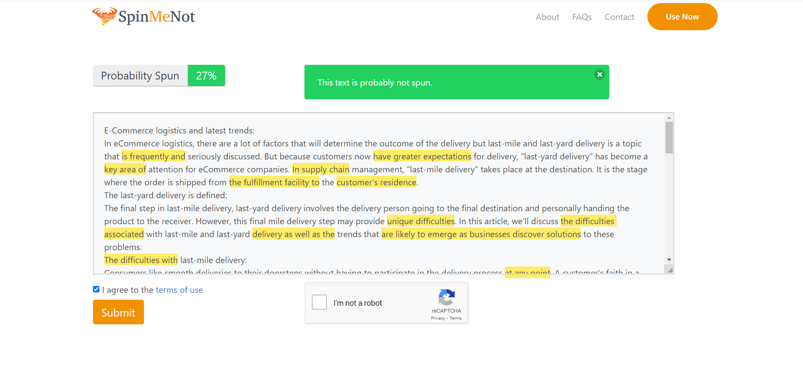

**Grammarly screenshot:**

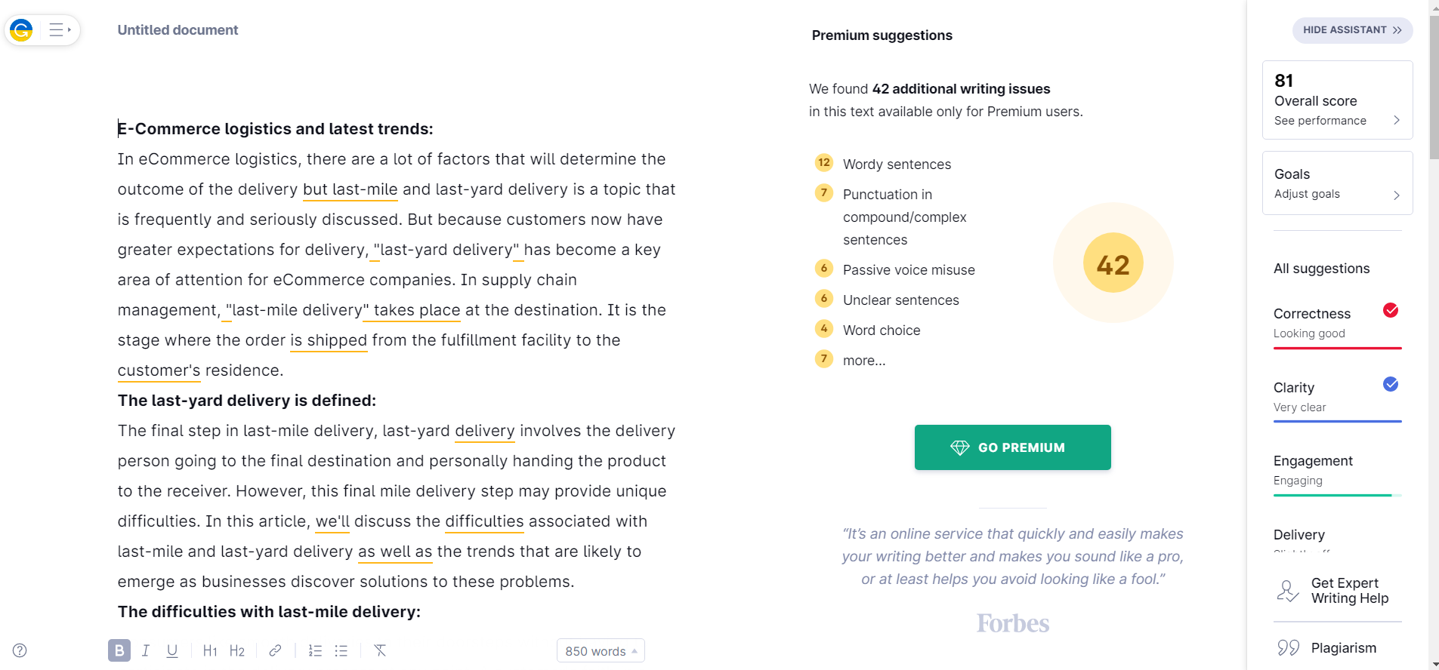

**Quetext screenshot:**

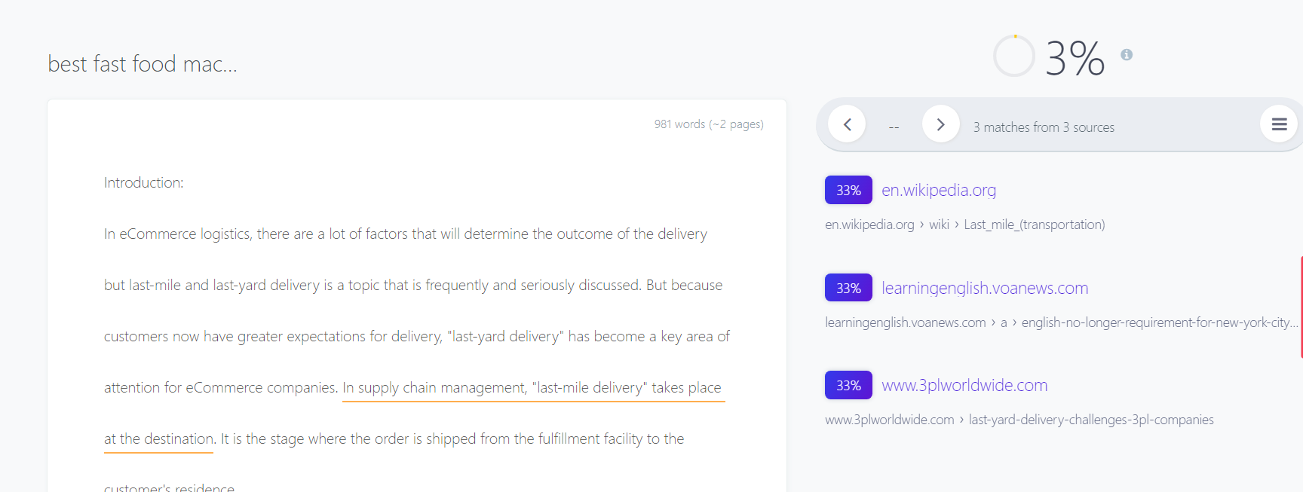

**-An Article by Sanjay M.**